
ASR Deployment Planner for Hyper-V
Setup Guide

Cognizant Microsoft Business Group
20 North Wacker Drive #530
Chicago, IL 60606

Notice of Confidentiality ©2021 Cognizant Microsoft Business Group All rights reserved.

IS SUBJECT TO THE TERMS OF THE COGNIZANT MICROSOFT BUSINESS GROUP NON-DISCLOSURE AGREEMENT. NEITHER THIS DOCUMENT NOR ITS CONTENTS MAY BE REVEALED OR DISCLOSED TO UNAUTHORIZED PERSONS OR SENT OUTSIDE THE AFOREMENTIONED COMPANY WITHOUT PRIOR PERMISSION FROM COGNIZANT MICROSOFT BUSINESS GROUP.
MAGNITUDE.
Table of Contents
Summary 3
Prerequisites 3
Deployment 4
Setup Input Data 4
Start Profiling 5
Generate Reports 6

Summary
This guide outlines the deployment of the ASR Deployment Planner Tool. Before beginning, please verify the requirements are met In the Support Matrix section In the ASR Deployment Planner Documentation.

Prerequisites
The ASR Deployment Planner will need the following prerequisites configured before deployment of the tool.
☐ | A service account provisioned that will be used to access the Hyper-V hosts/clusters. This account will need administrator rights.
☐ | For Profiling and Throughput Measurement - A server with the following configuration to host the deployment planner tool and components:  - Operating system: Windows Server 2016 or Windows Server 2012 R2  (ideally matching at least the size recommendations for the configuration server)  - Machine configuration: 8 vCPUs, 16 GB RAM, 300 GB HDD  - .NET Framework 4.5  - Visual C++ Redistributable for Visual Studio 2012  - Internet access to Azure from this server  - Azure storage account for throughput calculation  - Administrator access on the server  - Minimum 100 GB of free disk space (assuming 1,000 VMs with an average of three disks each, profiled for 30 days)  - The VM from where you are running the Azure Site Recovery deployment planner tool must be added to TrustedHosts list of all the Hyper-V servers. For more information on how to add the servers to the list, refer to the following Microsoft Documentation.  - All Hyper-V servers to be profiled must be added to TrustedHosts list of the client VM from where the tool is being run.  - The tool should be run from Administrative privileges from PowerShell or command-line console on the client
☐ | For Report Generation – A Windows PC or Windows Server with the following configuration:  - Excel 2013 or later.  - Administrator account for access to the Hyper-V host/cluster during profiling operations  - All hosts that are going to be profiled need to have a domain administrator account with the same credentials.  Note: This machine is optional, the above server can be used for this purpose if desired.

Deployment
To deploy the Windows Virtual Desktop service, follow the steps below.
- Consent to Windows Virtual Desktop (WVD) service for the tenant
  - Open your Azure portal and navigate to the Azure Active Directory Overview. Copy your tenant ID listed here
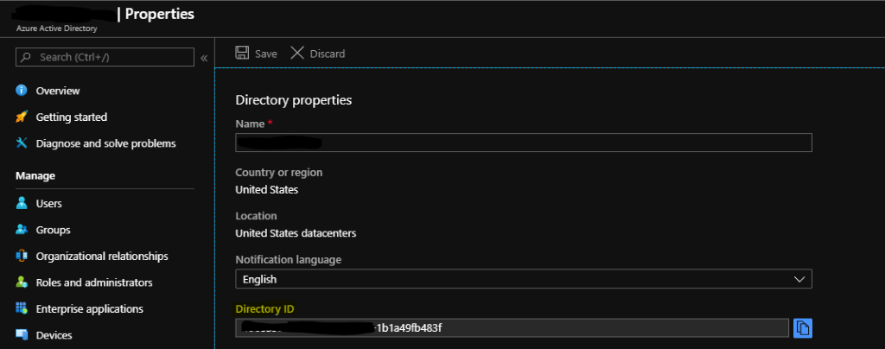
  - Go to the site to consent to WVD, enter the Directory Id you just copied, and click submit.
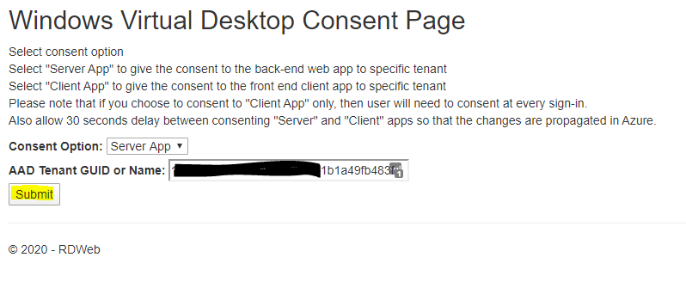
  - You will be prompted to sign in, you must use an account that has been assigned the Global Administrator role.
  - Then click accept on the list of permissions to be granted
  - Repeat this same process, changing the Consent Option drop down box to “Client App.”
- Assign TenantCreator Role to Azure AD Users
  - Navigate to Azure Active Directory, under the Enterprise Applications blade.
  - Find the “Windows Virtual Desktop”, this was created when consent was granted.
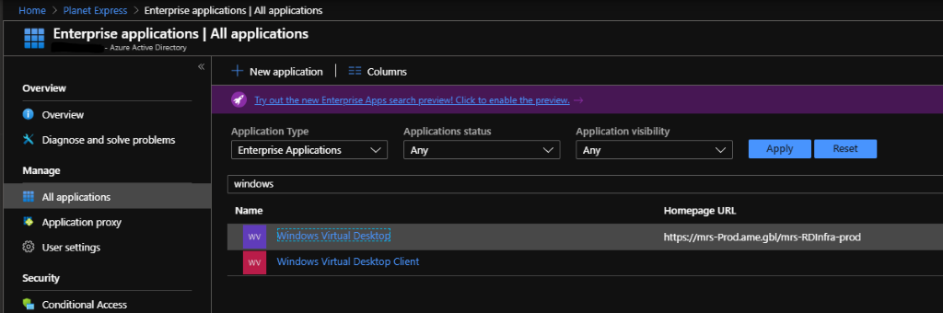
  - Within the application, navigate to the Users and Groups Blade.
  - Add any users that need access, and assign the “TenantCreator” role.
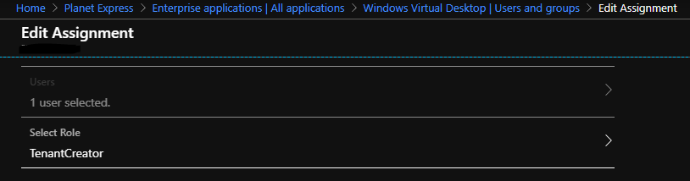

- Create WVD Tenant
  - Open an Administrator Powershell instance
  - Use the following commands to verify the proper modules are installed.
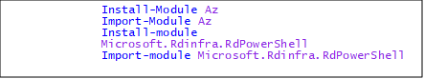

  - Use the next commands to authenticate to the RDS powershell service, do not change the URL, and to create your new tenant.
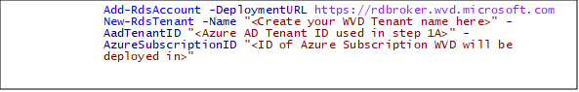
$TenantGroupName = “Default Tenant Group
$tenantName = (get-rdstenant).Tenantname
- Create service principal in Azure AD and assign permissions
  - Use the following 3 commands to create a service principal and credentials that will be used to create this hostpool and future hostpools.
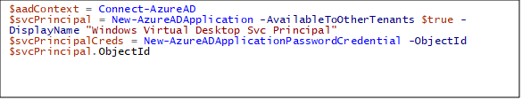
  - Use the next commands to add the RDS owner role to the service principal that was created
  - $svcPrincipal.AppId
  - $svcPrincipalCreds.Value
  - $aadContext.TenantId.Guid
  - #set permissions for SVC Principal
  - New-RdsRoleAssignment -RoleDefinitionName "RDS Owner" -ApplicationId $svcPrincipal.AppId -TenantName $TenantName

- Create the Hostpool
  - In the Azure portal, click on the “Create a Resource option.
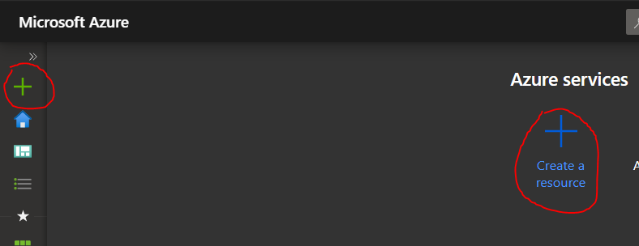
  - Search for “Windows Virutal Desktop – Provision a host pool” then click create
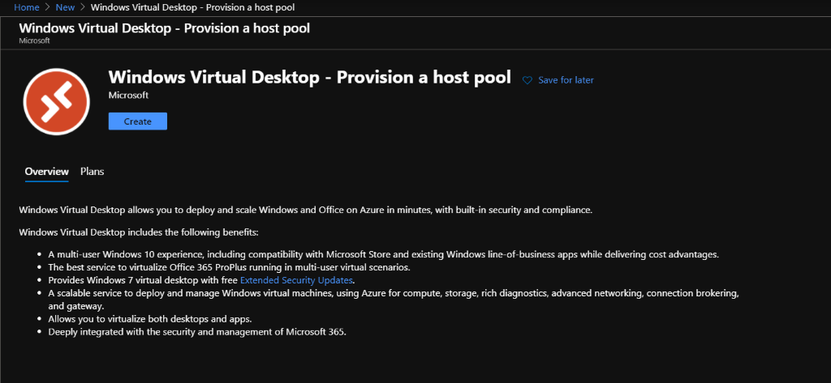
  - Specify the basics of where the host pool will be deployed
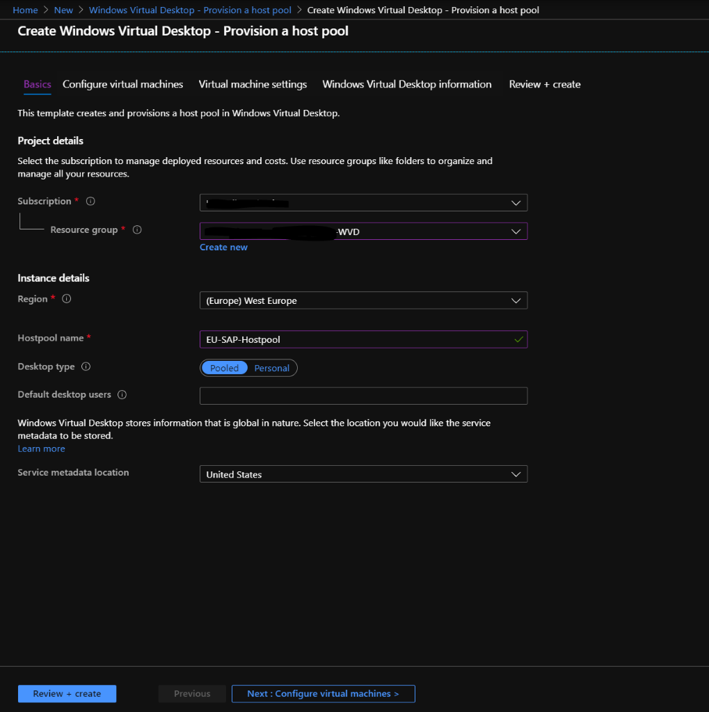
    - Subscription: Make sure to use the same subscription that was used in earlier steps
    - Resource Group: Choose a resource group that will host all the created resources
    - Region: Choose a region that best matches the geographical location of the users that will connect to the hostpool
    - Hostpool name: Create a hostpool name that is unique to your subscription
    - Desktop Type: Choose the option that best matches your needs
      - Pooled: Multiple users will connect to the same VM. Good if you plan on publishing specific remote apps for users rather than full desktops. This option can make use of Windows 10 Multi Session.
      - Personal: Each session host will be assigned to an individual user. This option provides a persistent VM for each user. It will require more VMs than a pooled type, as each VM can only be used by one user at a time.
    - Default desktop users: Enter a comma separated list of users that will be added to the default desktop group at creation. Users can be added after creation of the host pool as well.
    - Service metadata location: At the time of writing, United States is the only option for metadata storage.
  - Configure Virtual Machines
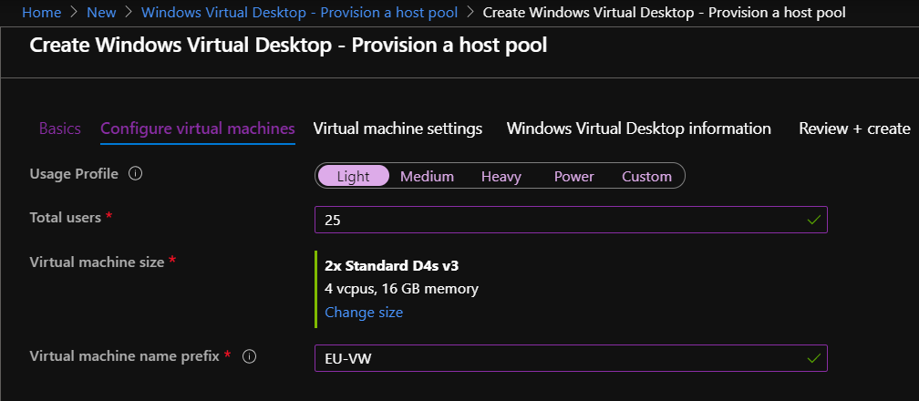
    - Usage Profile: This setting will determine the number of VMs that the hostpool will contain to start with. You can specify a custom number of VMs as well.
    - Total Users: This will determine the number of VMs needed based off a combination of the usage profile and total users
    - Virtual Machine Size: Choose a machine size that will be deployed, this defaults to a standard D4s v3 but can be changed to suit your environment's needs.
    - Virtual machine name prefix: This will determine the naming scheme of the hostpool VMs. For instance, if you named it EU-VW, it would deploy them as EU-VW-0, EU-VW-1, etc.
  - Virtual Machine Settings
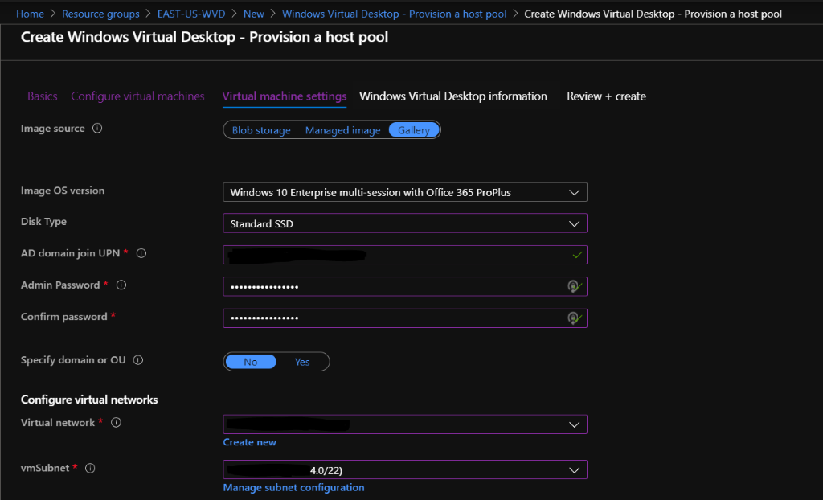
    - Image Source: You can choose an image from the gallery, or a preexisting managed image, or an image stored in blob storage
    - Disk Type: Choose the Disk SKU that will be used for all VMs created
    - AD domain join UPN and Admin Passwords: Specify the UPN and password of an account that can add VMs to the domain
    - Specify domain or OU: You can optionally specify the domain and OU path to join the created VMs to
    - Configure Virtual Networks: Choose an existing Vnet and Subnet for the resources to be deployed to. Note: Even though it gives the option to create a new Vnet in this step, it must be created before provisioning the host pool.
  - Windows Virtual Desktop Information
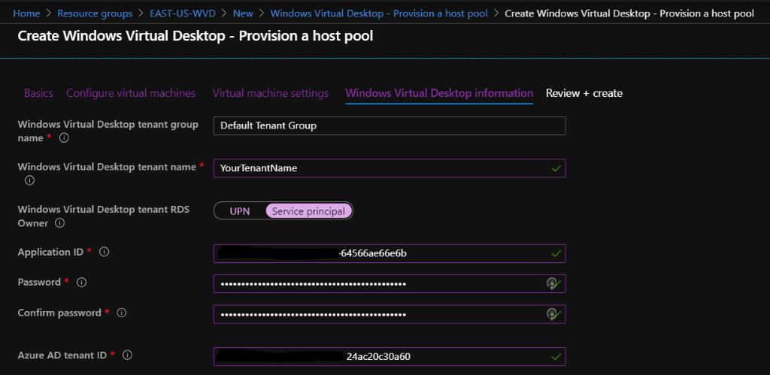

    - Windows Virtual Desktop Tenant Name: This should be left as Default Tenant Group
    - Windows Virtual Desktop Tenant Name: This must be the same as the tenant name created earlier in step 3C
    - It is recommended to use the Service Principal created earlier for this step. To get the Application ID, find the service principal in your Azure Active Directory or run $svcPrincpal.AppID in powershell from earlier
    - For the Service Principal password use the $svcPrincipalCreds.Value in powershell. Or create a secret from Azure active directory from the portal. Make note of this password, you will be unable to retrieve it later.
    - You can get the Azure AD Tenant Id from Azure Active Directory in the portal, or use $aadContext.TenantId.GUiD in powershell.
    - Review and Create: Verify that all settings are correct and that there are no validation errors. The provisioning process can take anywhere from 20 minutes to an hour depending on how many VMs are being deployed.
- Test connection
  - Navigate to https://rdweb.wvd.microsoft.com/webclient/index.html in your browser. Sign in with one of the accounts you specified as a default Desktop user during step 5C. From here, there should be a default session you are able to connect to and use as a standard Windows workstation.
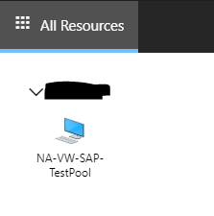
  - Connecting to this workstation will prompt you to allow the clipboard and printers to be shared to the Virtual desktop. Once you allow or deny this, you will be prompted for domain credentials, the same that was used to sign into the web portal.
  - Alternatively, you may download the desktop client here https://docs.microsoft.com/en-us/azure/virtual-desktop/connect-windows-7-and-10

Setup Input Data
- Add or remove Users to a desktop or application group
  - Back to the same powershell session from earlier, use these commands to add and remove users from groups in the RDS Hostpool
$hostpoolname = “<Name you used to create the hostpool in step 5.C.iv.>”
#To add a user
Add-RdsAppGroupUser -TenantName $TenantName -HostPoolName $hostpoolname -AppGroupName "<Application group name>” -UserPrincipalName "<UPN of user to be added>”

#To remove a User
Remove-RdsAppGroupUser -TenantName $TenantName -HostPoolName $hostpoolname -AppGroupName "<Application group name>” -UserPrincipalName "<UPN of user to be removed>”
  - NOTE: A user can not be a member of the desktop application group and a remote app group. However, a user can be a member of multiple remote app groups
- Create a new RemoteApp Group
  - Run this command to create a new RemoteApp Group
New-RdsAppGroup -TenantName $TenantName -HostPoolName $hostpoolname -name <"RemoteAppGroupName"> -Description <"An optional friendly description for the app group if needed">
- Publish remote apps to a group
  - Use the following commands to return a list of all apps that are available to be remote published.
$appgroupname = <"RemoteAppGroupName">
Get-RdsStartMenuApp -TenantName $TenantName -HostPoolName $hostpoolname -AppGroupName $appgroupname
#alternatively, run this command to return only the app names rather than the entire information block for each
Get-RdsStartMenuApp -TenantName $TenantName -HostPoolName $hostpoolname -AppGroupName $appgroupname | fl AppAlias
  - Use the following command to publish an app based off its AppAlias, in this example we will use Microsoft Word.
New-RdsRemoteApp -TenantName $TenantName -HostPoolName $hostpoolname -AppGroupName $appgroupname -Name Word -AppAlias Word
#Alternatively, use this command to install an app without an alias or to install it manually
New-RdsRemoteApp -TenantName $TenantName -HostPoolName $hostpoolname -AppGroupName $appgroupname -Name Word –Filepath “<filepath>” -Icon “<filepath to the Icon>” -IconIndex “<filepath to the icon index>”
  - To check if the app has been successfully published, navigate back the Remote Desktop Web Client and refresh the page. If the account you are signed into is a member of the app group, you should see your published app here.
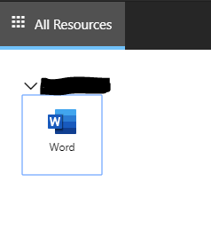
- Configure the HostPool Load Balancer
  - By Default, the HostPool is set to use to a Breadth-first type of load balancer, meaning that users will be evenly spread across all VMs in a hostpool. The other option is a depth-first load balancer, which will put users on a single VM until it hits the Max Session Limit that you set with the load balancer type.
  - To set a Depth-first load balancer, use the following powershell command:
set-rdshostpool -TenantName $tenantname -name $hostpoolname -DepthFirstLoadBalancer -MaxSessionLimit 99
- Create a managed image in Azure
  - Login to the VM that you wish to use to create the image to deploy to WVD hosts
  - It is recommended that you create a Snapshot of the disk before the next steps
  - Open Command prompt as an administrator
    - Navigate to the c:\windows\system32\sysprep directory
    - Use the command sysprep.exe
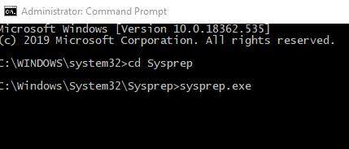
    - Make sure to check the box next to generalize and set the shutdown options to Shutdown
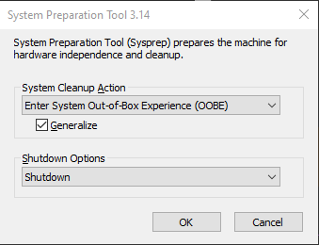
After you click ok, the VM should automatically shut down and be ready for image capture.
  - Navigate to the shutdown VM in Azure then use the capture option
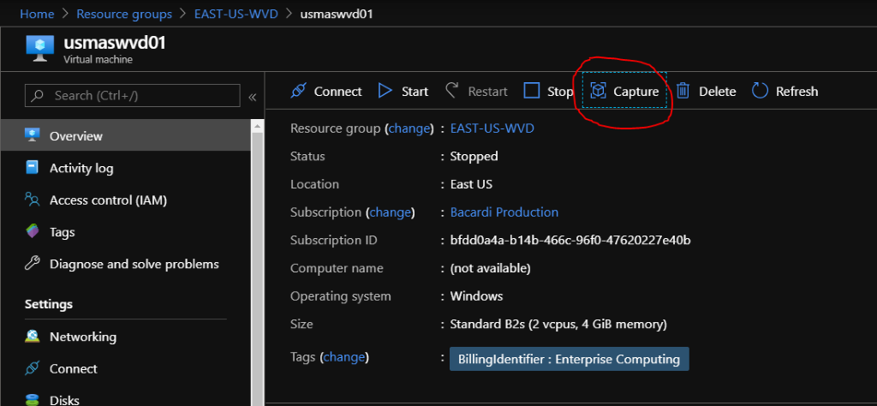
    - Enter the name and resource group of the image you are creating.
    - You can optionally check the box to automatically delete this virtual machine after creating the image
    - Type the virtual machine name that is being used to create the image to proceed then click create
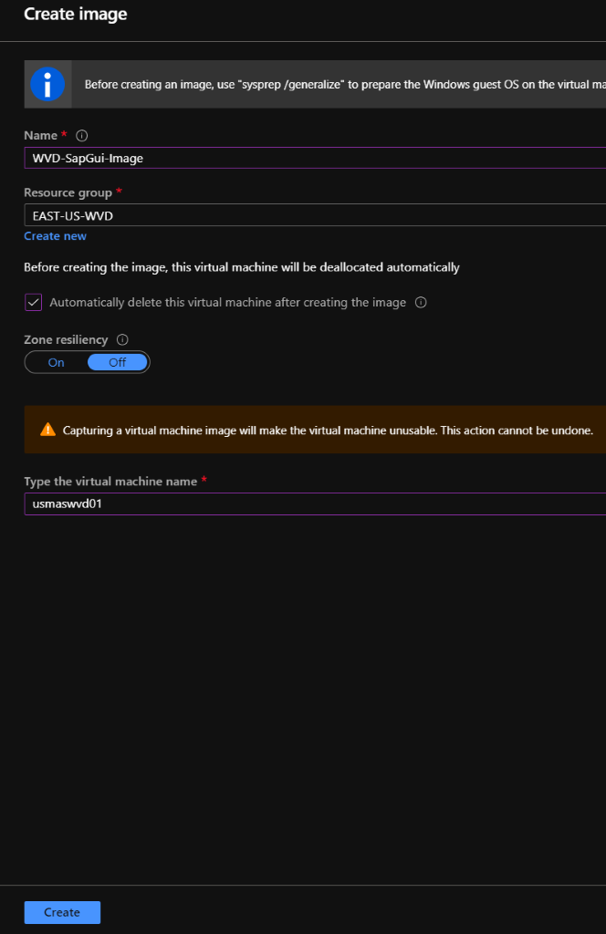

- Configure the HostPool Load Balancer

- Configure the HostPool Load Balancer

Start Profiling

Now that a list of VMs to be profiled has been created, you can run the tool in profiling mode. Below are some common examples of how to run the tool. The full list of all parameters and options can be found in the ASR Deployment Planner Documentation.
- Open an elevated command prompt
- Change to the directory that you extracted the ASR Deployment Planner
- Run ASRDeploymentPlanner.exe with the desired options
Examples
Note: We recommend that you run the profiling for more than 7 days for best results.
To save the profiling data locally to the server, you'd run with similar options:
ASRDeploymentPlanner.exe -Operation StartProfiling -Virtualization “Hyper-V” -Directory “<profile data directory>” -VMListFile “<input file path>” -NoOfDaysToProfile <number days to profile> -User <Hyper-V username> -StorageAccountName <name> -StorageAccountKey <access key>
To save the profiling data to a share or another server, you'd run with similar options:
ASRDeploymentPlanner.exe -Operation StartProfiling -Virtualization “Hyper-V” -Directory “<\\profile-data-share>” -VMListFile “<input file path>” -NoOfDaysToProfile <number days to profile> -User < Hyper-V username > -StorageAccountName <name> -StorageAccountKey <access key>

By default, the tool is configured to profile and generate report up to 1000 VMs. You can change limit by changing MaxVMsSupported key value in the ASRDeploymentPlanner.exe.config file. You can also run multiple instances of the tool with multiple input files.

<!-- Maximum number of vms supported-->
<add key="MaxVmsSupported" value="1000"/>

Note: If you have multiple servers, you need to run one instance of ASRDeploymentPlanner for each Hyper-V host for profiling.

Generate Reports
After profiling is complete, you need to run the tool in report generation mode. The tool generates a macro-enabled Microsoft Excel file (XLSM file) as the report output, which summarizes all the deployment recommendations. The report is named DeploymentPlannerReport_<unique numeric identifier>.xlsm and placed in the specified directory. Below are some common examples of how to run the tool. The full list of all parameters and options can be found in the ASR Deployment Planner Documentation.
- Open an elevated command prompt
- Change to the directory that you extracted the ASR Deployment Planner
- Run ASRDeploymentPlanner.exe with the desired options
Examples
To generate a basic report for testing and save It locally to the server, you'd run with similar options:
ASRDeploymentPlanner.exe -Operation GenerateReport -Virtualization “Hyper-V” -Directory “<profile data directory>” -VMListFile “<input file path>”
To generate a basic report for testing and save to a share or another server, you'd run with similar options:
ASRDeploymentPlanner.exe -Operation GenerateReport -Virtualization “Hyper-V” -Directory “<\\profile-data-directory>” -VMListFile “<\\input-file-path>”
To generate a report with RPO, bandwidth, and subscription cost analysis:
ASRDeploymentPlanner.exe -Operation GenerateReport -Virtualization “Hyper-V” -Directory “<profile data directory>” -VMListFile “<input file path>” -DesiredRPO <minutes> -Bandwidth <number of Mbps> -SubscriptionId <subscription Id>

